fCHAPTER NO 9

SYETEM SOFTWARE

DEFINATION:

Systems software controls the operation of a computer. Without systems software a computer would not function. The most important piece of systems software is the operating system. The operating system will perform vital tasks such as:

Managing communications between software and hardware.

Allocating computer memory to other software programs.

Allocating CPU time to other software programs.

EXAMPLES:
- Operation systems
- Utility program
- Programming languages
- Device drivers

OPERATING SYSTEM
The operating system is a very special piece of software. All the other applications software such as databases and spreadsheets communicate with the computer hardware through the operating system. The operating system controls the overall operation of the computer.
DEFINITION:
“An operating system (or OS) is a computer program which controls the entire operation of the computer. Computer software applications communicate with the computer hardware via the operating system”.

Example Operating Systems
When you buy a computer it is usually supplied with an operating system already installed. You will not be able to use a computer without an operating system. Different operating systems are available for different types of computer and different purposes. Some popular operating systems are:

- Microsoft windows
- Disk Operating System (DOS)
- Linux
- Unix

The choice of operating system will affect how a computer works. It will probably determine the type of user interface (command line, menu driven or graphical) that the computer uses and the types of processing (batch, transaction or real-time) that the computer can carry out.

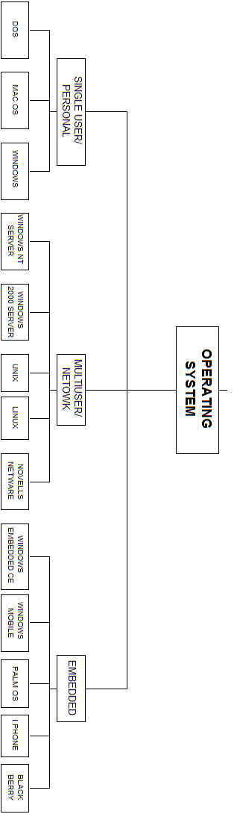

COMMAND LINE INTERFACE:

Command Line Interface (CLI) lets you control your PC by typing commands. In the figure below is command line interface. There's no mouse or graphical controls like you get in a GUI such as Windows.

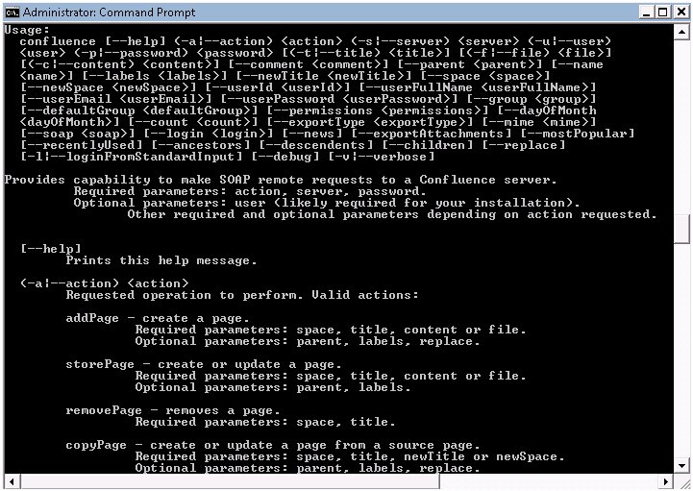

GRAPHICAL USER INTERFACE (GUI):
“A graphical user interface (GUI, pronounced "gooey") is a computer environment that simplifies the user's interaction with the computer by representing programs, commands, files, and other options as visual elements, such as icons, pull-down menus, buttons, scroll bars, windows, and dialog boxes.”
By selecting one of these graphical elements, through either use of a mouse or a selection from a menu, the user can initiate different activities, such as starting a program or printing a document
As define in that figure:
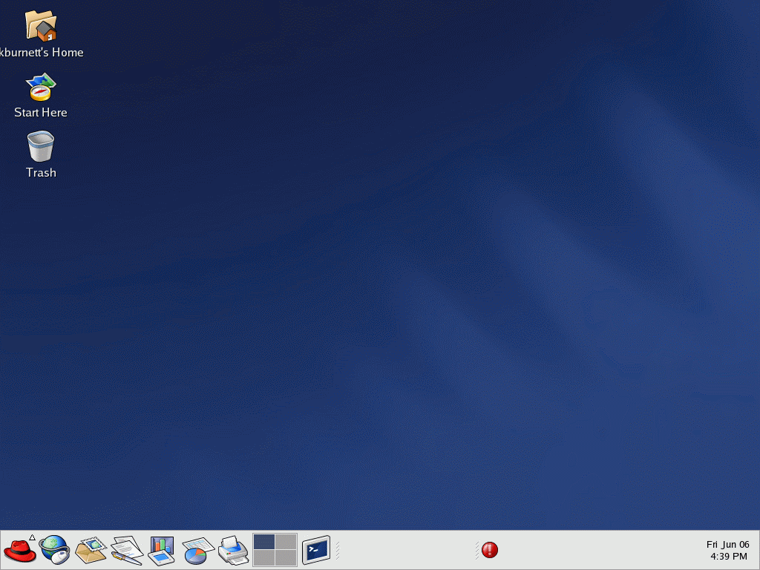

TASKS PERFORMED BY AN OPERATING SYSTEM
There are several tasks which are performed by practically all operating systems, regardless of the complexity of the computer the operating system is being used on. These tasks include:
- Managing communications between software and hardware.
- Allocation of computer memory.
- Allocation of CPU time.
- Run and Manage program
- Managing files
- Configure Software and Devices
- Configure Network
- Coordinating Tasks
- Performance Management

The range of tasks that an operating system performs increases if the computer using the operating system is on a network or if the operating system is a multi-tasking or multi-user operating system.

MANAGING COMMUNICATIONS BETWEEN SOFTWARE AND HARDWARE
There are many tasks which practically every program written for a computer will need to carry out. For example:
- Loading and saving data and programs.
- Communicating with peripherals such as a mouse or a printer.
- Organizing data stored on a hard disk.
- Displaying information on the VDU.
Therefore the operating system manages all of these tasks. If, for example, a program wants to save or print a file it must send a request to the operating system asking it to do so. The operating system will then carry out the task.
Because an application such as a spreadsheet works by communicating with the operating system the application will probably only work with one particular operating system. If you buy Microsoft Works for Windows 95 it will only operate on computers with the Windows 95 operating system. If you want to use Microsoft Works with the MS-DOS operating system you will have to buy a different version of the application.
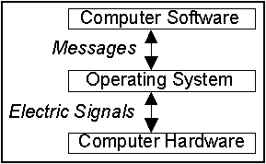
Putting commonly used operations such as saving data into the operating system also reduces the amount of work that a person writing a new application must do.

ALLOCATION OF COMPUTER MEMORY
Computer memory must be allocated to (divided between) the different tasks that the computer is performing. Even if your computer appears to be doing only one task such as word processing there will be several different items to which memory must be allocated.
For example memory would have to be allocated to storing the word processor program, storing your word processed document and storing a copy of the screen that is being displayed on the monitor. And of course the operating system itself will also use up some memory.
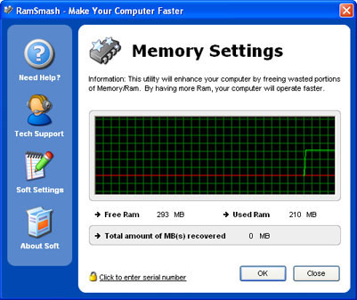

ALLOCATION OF CPU TIME
Most computers have only one Central Processing Unit (CPU) or microprocessor. The CPU can only process one piece of data at a time. Therefore the CPU’s time must be divided up between all of the tasks that the computer is currently carrying out. If you were printing a document form a word processor application then the CPU’s time would need to be divided up between:
- Letting you type on the computer.
- Sending the document that is being printed to the printer.
- Updating the screen display to show you what is going on.
- RUN AND MANAGE PROGRAM
The operating system manages all the other programs that run on the computer. The operating system provides services to programs and the user, including file management, memory management, and printing. It provides services to programs, the OS makes system call requesting other hardware and software resources to perform tasks.

- MANAGE FILES
Operating system manages and organizes all files in system. The operating system keeps track of all the files on each disk. Users can make file management easier by creating a hierarchical file system that includes folders and subfolders arranged in a logical order.
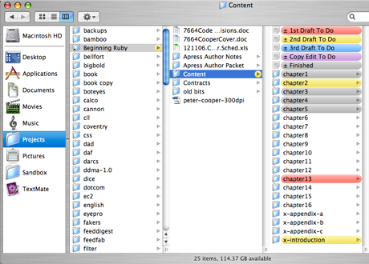

CONFIGURE SOFTWARE AND HARDWARE

Operating system is maintaining organized communication with the process and hardware. Each hardware device is controlled by Software, which allows the OS to activate and use the device. The operating system provides the software and hardware connection in order to use that hardware.

OPERATING SYSTEM
HARDWARE
SOFTWARE

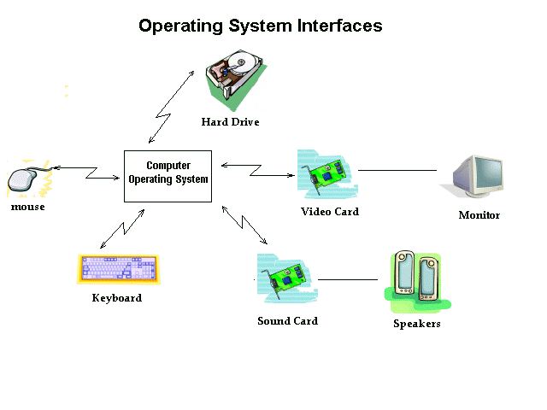

- CONFIGURE NETWORK
Operating system manages and configures network and internet connections it provide the platform on which computer networking takes place. Operating system provide basic features for allow for file, print and Internet connections.
OS configured and managed through network operating system utility.

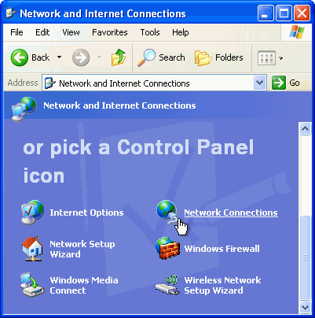

- COORDINATING TASKS

Operating system controls the order and time in which programs are run and is more difficult in the mainframe environment where scheduling the daily work has always been routine. In a desktop environment, batch files can be written to perform a sequence of operations that can be scheduled to start at a given time.

Multitasking, which is the ability to simultaneously execute multiple programs, is available in all operating systems today. Multitasking is necessary for keeping several applications open at the same time so you can bounce back and forth among them

- PERFORMANCE MANAGMENT
Operating system given the increased complexity of processors and applications, the current generation of Operating Systems (OSs) focuses mostly on software integrity.
Operating System managed with performance by resource partitioning (virtualization), CPU cycles, clock speed, memory and I/O bandwidth, and main/cache memory space.

TYPE OF OPERATING SYSTEM

An operating system is a software component of a computer system that is responsible for the management of various activities of the computer and the sharing of computer resources.

Users and application programs access the services offered by the operating systems, by means of system calls and application programming interfaces. Users interact with operating systems through Command Line Interfaces (CLIs) or Graphical User Interfaces known as GUIs as defined above.

In short, operating system enables user interaction with computer systems by acting as an interface between users or application programs and the computer hardware.

The types of Operating systems are here under:

  - Single user/personal computer operating system
  - Multiuser/network operating system
  - Embedded operating system

SINGLE USER/PERSONAL COMPUTER SOPERATING SYSTEM:
The most basic type of operating system can only carry out one task at a time and can only be used by one person at a time. More sophisticated multi-tasking and multi-user operating systems can appear to carry out more than one task and be used by more than one user at the same time.

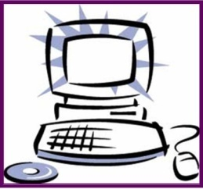


It has further types
- DOS
- MAC OS
- Windows

DISK OPERATING SYSTEM (DOS):

DOS stands for “Disk Operating System”. It is single user operating user has command line interface. DOS is product of Microsoft but developed for another company named as IBM.

DOS uses a command line, or text-based interface, that allows the user to type commands. By typing simple instructions such as pwd (print working directory) and cd (change directory), the user can browse the files on the hard drive, open files, and run programs. While the commands are simple to type, the user must know the basic commands in order to use DOS effectively.


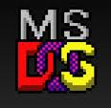

MAC OPERATING SYSTEM:

Mac OS X is Apple's operating system for its line of Macintosh computers. Its interface, known as Aqua, is built on a Unix foundation.
it has much of the look and feel of the former Mac OS, features such as preemptive multitasking, symmetric multiprocessing, multithreading, and protected memory give Mac OS X improved stability and performance.

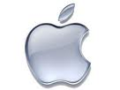
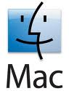

WINDOWS OPERATING SYSTEM:

Windows is a personal computer operating system from Microsoft. Operating system designed and produced by Microsoft Corporation. Similar to other operating systems, Windows makes a computer system user-friendly by providing a graphical display and organizing information so that it can be easily accessed.
The operating system utilizes icons and tools that simplify the complex operations performed by computers. Estimates suggest that 90% of personal computers use the Windows operating system. Microsoft introduced the operating system in 1985 and it has continued to be widely used despite competition from Apple's Macintosh operating system.
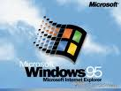
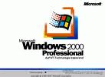
It has many versions like
- Windows 95
- Windows 2000
- Windows 2000 XP
- Windows vista
- Windows 7
- Windows me
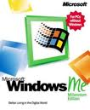
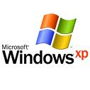
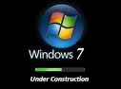

MULTIPLE USER/NETWORK OPERATING SYSTEM:
Multi-user operating systems are used on large mainframe computers. A mainframe computer system has one very powerful processing unit. Many users will all share this processing unit. They use terminals (a keyboard and a screen) to access the mainframe computer.
A multi-user operating system lets more than one user work on a mainframe computer at the same time.

Operating systems that are used on computers connected to networks usually have to carry out some additional tasks. Probably the most important of these is managing system security. Important aspects of systems security that an operating system might manage are :
- Controlling who has access to which files.
- Keeping a log of all of the files that a user changes.
- Automatically backing up important files.
These operating systems are more complicated and require faster hardware and more memory to work than more basic operating systems.
It has further types
- WINDOWS NT SERVER
- WINDOWS 2000 SERVER
- UNIX
- SOLARIS/LINUX
- NOVEL’S Novell’s

WINDOWS NT SERVER:

Windows NT is a Microsoft Windows personal computer operating system designed for users and businesses needing advanced capability.
NT's technology is the base for the Microsoft successor operating system, Windows 2000. Windows NT (which may originally have stood for "New Technology”, is actually two products: Microsoft NT Workstation and Microsoft NT Server.
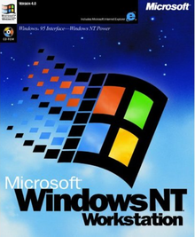

WINDOWS 2000 SERVER:

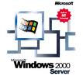
Window 2000 server is also product of “Microsoft” and advance version of Windows NT server. It is designed to appeal to small business and professional users as well as to the more technical and larger business market. It is consist of three products
- Windows 2000 server
- Windows 2000 Advance server
- Windows 2000 data center server

UNIX:

By the simplest definition, UNIX is a computer operating system - the base software that controls a computer system and its peripherals. In this sense, UNIX behaves in the same way that the perhaps more familiar PC operating systems
UNIX is a powerful, flexible, computer operating system designed for multi-user applications (such as networks). It is the most frequently used operating system for servers on the World Wide Web.
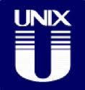

SOLARIS/LINUX:

The Solaris Operating System (Solaris OS) is another version of UNIX. Solaris is the computer operating system that Sun Microsystems for Intel-based processors.
Sun has historically dominated the large UNIX workstation market. As the Internet grew in the early 1990s, Solaris systems became the most widely installed servers for Web sites. Solaris has its large number of features, and its Internet-oriented design.


NOVELL’s NETWARE:

A family of network operating systems from Novell that support Windows, Macintosh, DOS and OS/2 clients. UNIX client support is available from third parties.
In the early 1990s, NetWare was the largest installed base of LAN operating systems. It eventually gave way to UNIX, Linux, Windows and Mac running the IP protocol.
NetWare, made by Novell, is a widely-installed network server operating system. Initially very successful in installing its products in large and small office local area networks (LANs), Novell redesigned (or at least re- featured) NetWare to work successfully as part of larger and heterogeneous networks, including the Internet. An early - and primary competitor was the Microsoft Windows NT operating system.
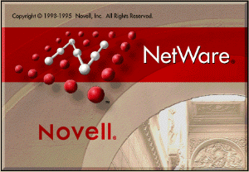

3) EMBEDDED OPERATING SYSTEM

An embedded operating system is an operating system for embedded computer systems. Due to the very nature of embedded systems, the operating system has different constraints compared to other desktop OS.
These devices have operating system in ROM. Many handheld devices have the embedded operation systems like PDA, palm device, tablet pc etc

Types of embedded OS are here under:
- Windows Embedded CE
- Windows mobile
- Palm operating system
- I phone OS
- Black berry Operating System
WINDOWS EMBEDDED CE
This operating system is designed for some portable and web based devices which have different features like Communication, internet, entertainment & different application programs like MS Word & Excel etc
It has many features like other operating system which is designed by Microsoft like for entertainment it has windows media player, we can perform multitasking in these devices. We can check email and browse websites.
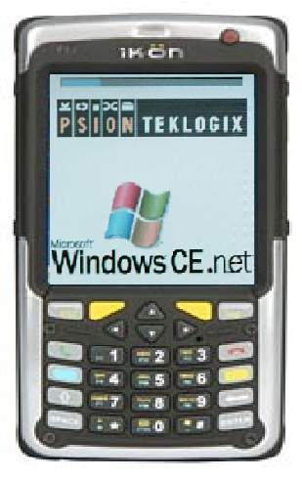

WINDOWS MOBILE
This operating system is same like Windows CE but it is specially designed for some PDA (Personal Digital Assistant) and other mobile devices.
It has same features like Windows CE but by windows mobile any user can access its contacts from address book, schedule his tasks and set the notes and meetings on it.

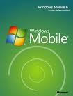
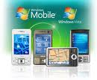

PALM OPERATING SYSTEM
This operating system is designed for some devices which we can hold in hand and portable.
Palm operating system that provides a software platform for the Palm series of handheld personal digital assistants (PDAs) made by Palm Inc. According to Palm, Palm OS was designed from the beginning to fit into a palm-size device of a specific size and with a specific display size.
Palm OS has Dates, Address Book, To Do Lis, Memo Pad, Calculator, and special Password Protection.

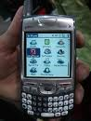

I PHONE OPERATING SYSTEM
This is designed for special based devices which have capability to work with touch screen and touch pad, I phone and I Pad Touch. By the help of your fingers all objects can functioned.

The I Phone Touch has the same applications that are present by default on the other PDAs but, with the exception of the Phone, Messages, Compass and Camera apps. It also has two applications of Music, and Videos.
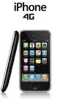

BLACK BERRY OPERATING SYSTEM
It is designed for a handheld device named as black berry. That operating system provides web capabilities like email, chatting, text messages, multimedia massages and can access different remote devices with Blue tooth technology. It also provide interface to take pictures, record videos and has GPS (Global positioning system).
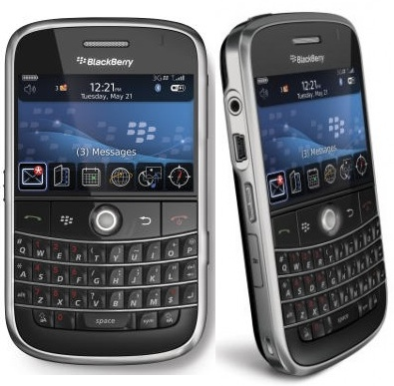

UTILITY PROGRAM
A program that performs a specific task related to the management of computer functions, resources, or files, as password protection, memory management, virus protection, and file compression.
It is part that is used to provide services for the hardware and software but it is not absolutely required to run programs and, if it didn't come with the operating system, you could perhaps add it. In other usages, a utility is an application that is very specialized and relatively limited in capability.
Examples of some utilities are here under:
- Virus scanning software
- Backup software
- Scandisk
- Disk defragmenter

VIRUS SCANNING SOFTWARE

Virus Scanning Software is utility programs designed to protect your computer from computer viruses. Virus scanning software is critical to uses, due to the number of computer viruses (small computer programs created to disrupt and destroy computer files and/or operating system software).
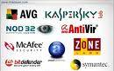
Virus scanning software scans your disk each time you insert it into a computer. If you receive a warning that there is a virus suspected on your disk then to eliminate the virus we have antivirus utility. If you own your own computer, you should have a good virus scanning software package installed. Remember - virus scanning software needs to be updated on a regular basis (usually monthly). Updates insure that your virus scanning software will protect you from the most recent viruses. Virus scanning packages come with directions on how to receive updates to your software. Some popular anti viruses are:
- MacAfee
- Avaira
- Norton
- Symantec

BACKUP SOFTWARE
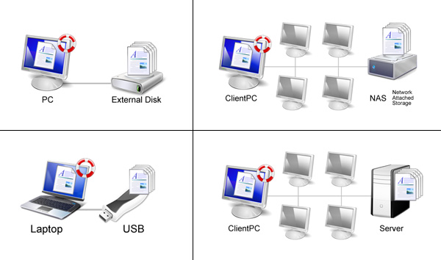
Backup software is software that assists you in backing up your files and even the entire computer hard drive. It is important for you to back up your files regularly. If you own your own computer, you should think about how to backup your valuable data on your hard drive, USB, and server. The server that houses your Home Folder is backed up regularly.

SCANDISK
Scandisk is a utility provided with Windows computers. Scandisk scans your disks to see if there are any potential problems on the disk, such as bad disk areas. Since disks are magnetic media, all disks, including your hard drive can be corrupted.
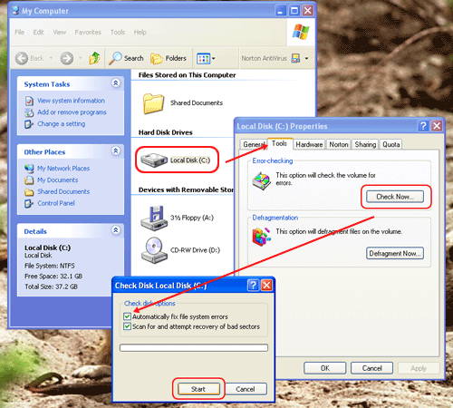

DISK DEFRAGMENTER SOFTWARE
Disk Defragmenter software assists you in keeps reorganizing your disk drives. After files are saved, deleted and resaved again, the disk can become fragmented --- available space is in small blocks located throughout the disk. Disk defragmenters gather those free spots and put them together to enable you to continue to save your data in the most efficient manner.

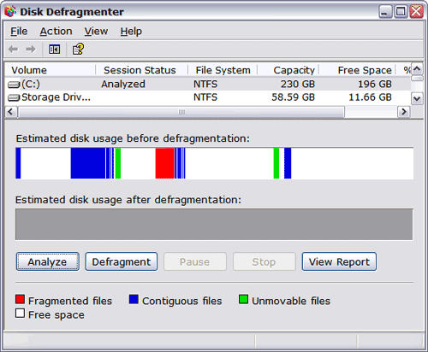

.

PROGRAMING LANGUAGES
A language in simple word is a way of communication for any person to other person in order to understand his talk.
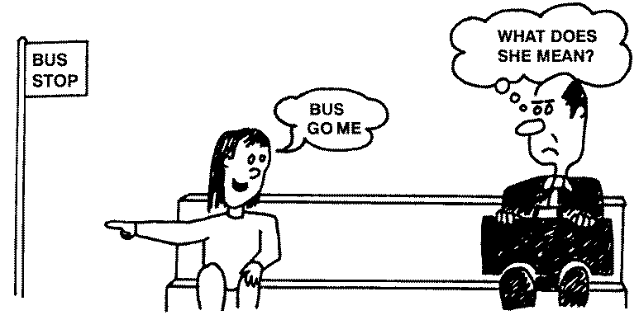

Like in the picture above a girl is communicating, the man who is sitting next to her. So the language is very important medium of communication like linguistics of human. Like human languages, each programming language has its own grammar and syntax. There are many components of the same language Computer also need a language so that it can communicate to the hardware and other important components of computer.
Definition:
A language used to write instructions for the computer. That is the way of representation any program in to that form which is understandable by CPU.
Reminder: program is written instruction for computer.
Programs are written by using any language and these languages set the procedures & rules to write computer programs. Programmers have to follow that rules which is set by programming languages.
TYPES OF PROGRAMMING LANGUAGES
According to structure, interface and procedure computer languages can be divided in to two major types.
- Low Level Language
- High Level Language
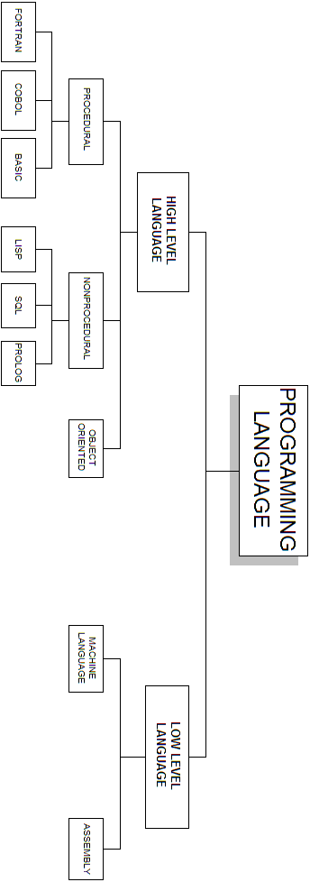

  - LOW LEVEL LANGUAGE
Low level language is also called machine language. That types of languages are close to machine and easily understand by machine as, it is majorly in binary form (0 & 1).low level language types are
- Machine language
- Assembly language
MACHINE LANGUAGE
This program written is this type of language sometimes referred to as machine code or object code, machine language is a collection of binary digits or bits that the computer reads and interprets. Machine language is the only language a computer is capable of understanding. Machine code is consisting of 0 & 1. Which mean off and on bit.
Program written in machine language is very fast but machine dependent. It is also referred as “First Generation Language”.
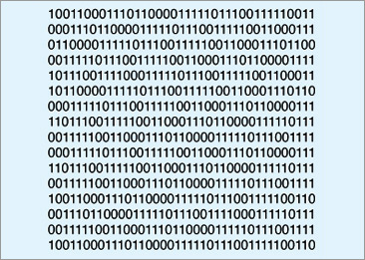

Machine code

ASSAMBLY LANGUAGE
Assemble language is also low level language close to machine language. It is also referred as assembly or ASL, assembly language and “Second Generation Language”.
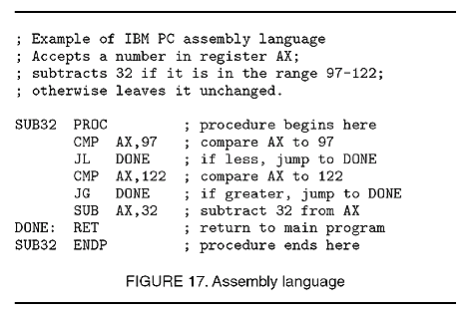

Assembly language

Assembly language used to interface with computer hardware. Assembly language uses structured commands as substitutions for numbers allowing humans to read the code more easily than looking at binary. Although easier to read than binary, assembly language is still a complex language
  - HIGH LEVEL LANGUAGE

High level programming languages is languages program than use languages or syntax which closes to human languages so; it is easy to understanding the languages. This type of language is machine-independent, and uses similar language as English, which is easily understandable by human.

TRANSLATOR

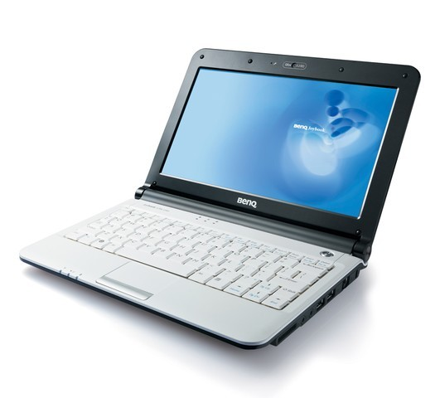

this type of language’s processing is slow as compared to high level languages. As, it need any translator between interface on computer and human. So, that both can understand their languages.

TYPES OF HIGH LEVEL LANGUGES
Types of high level languages are:
- Procedural Languages
- Functional & Non procedural Languages
- Object Oriented Languages
PROCEDURAL LANGUGES

The most common high-level languages today are procedure-oriented languages. In these languages, one or more related blocks of statements that perform some complete function are grouped together into a program module & procedure. These types of languages are “Third-Generation Language”.
The programmer defines the set of executable instructions and the exact sequence in which those instructions are to be executed. The computer simply obeys the instructions in the sequence it is told.
Procedural languages allow programs to be shorter and easier for the computer to read, but they require the programmer to design each.
Here are some types of procedural programming languages:
- FORTRAN (FORmula TRANslation)
- BASIC (Beginners All Purpose Symbolic Instruction Code)
- COBOL (Common Business Oriented Language)

NON PROCEDURAL LANGUGES
In non-procedural languages the computer is not limited to a set of precise instructions. Instead, the programmer defines only the problem--not the instructions--to solve the problem.
The computer determines the necessary steps to solve the problem. In essence, non-procedural languages emphasize the result (or what) is to be achieved rather than the methods (or how) a result is achieved. For example, to sort a list, the programmer instructs the computer to output a list in which adjacent items are in increasing or decreasing order.

Here are some types of Non Procedural Programming Languages:
- SQL (Structured Query Language)
- LISP (List Processing)
- PROLOG (PROgramming with LOGic)

OBJECT ORIENTED LANGUGES
Object-oriented languages are outgrowths of functional languages. In object-oriented languages, the code used to write the program and the data processed by the program are grouped together into units called objects. Objects are further grouped into classes, which define the attributes objects must have.
A simple example of a class is the class Book. Objects within this class might be Novel and Short Story.

NOVEL BOOK
BOOK
STORY BOOK

LANUAGE PROCESSOR
As, computer can understand only machine language; that’s why we need an interface between user and computer so that both can understand its instructions.

TRANSLATOR

Some types of language processors and translator are here under
- Compiler
- Interpreter
- Assembler
COMPILER
A compiler is a computer program that transforms human readable complete code of another computer program into the machine readable code that a CPU can execute.
INTERPRETER
An interpreter is a computer program that reads the source code of another computer program and executes that program.
Because it is interpreted line by line, it is a much slower way of running a program than one that has been compiled but is easier for learners because the program can be stopped, modified and rerun without time-consuming compiles.

ASSEMBLER
Assembler converts code written in assembly language into machine language. It works same like interpreter and compiler.
The assembler program takes each program statement in the code and generates a corresponding bit stream or pattern (a series of 0's and 1's of a given length).

